Sticky trap calibration experiment 2021
{literature review about legacy studies and the responsibility of caretakers to ‘calibrate’ them over time to account for changing conditions, sampling, etc}
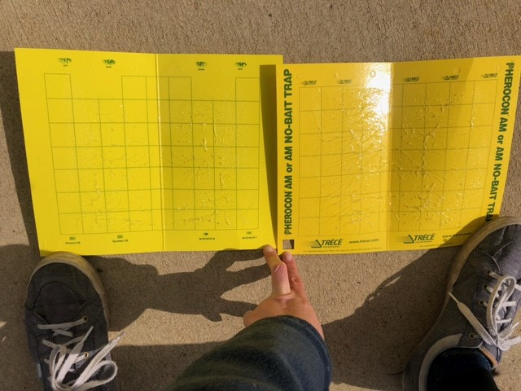
Traps used at KBS LTER for the last 32 years have been discontinued! The supplier is offering a similar product in its place but it’s slightly different. Photo is original trap on the left, new replacement trap on the right. We note that although structurally very similar, the new trap has a warmer, more saturated yellow color and also includes labelling down the side.
Problem: Insects are notorious for responding to slight differences in cues. (cite a million trap design studies). However, overlapping data can allow you to calibrate and standardize, if differences occur.
Question: Are the new traps collecting different communities of insects? If so, how do they differ?
Note: focus continues to be on ladybeetles, but should get metrics of other functional groups of insects as well just to determine how the traps might be behaving differently for other taxa. This also gives more statistical power to compare the traps and offers possible additional insights into how the traps might differ.
Experimental protocol:
This experiment is designed to employ KBS Ladybeetle monitoring as usual, with some slight modifications to allow tap comparisons and additional measurements. In short, traps will be labeled, grouped by plot, bagged and mailed to Kent State University after each collection.
Traps will be deployed for a two-week field exposure starting May 26 (and every 2 week period thereafter for the duration of the summer). Traps will be placed at all T- post sampling station within the Main Cropping System experiment and through the adjacent forest plots. Old style traps (no large text down the side) will be placed at stations 1, 3, and 5, and new style traps (with green writing on the sides) will be placed at stations 2 and 4 in all plots.
In week 1 after deployment, sampling will take place as usual using the provided data sheets. Ladybeetles and relevant predator groups will be recorded and removed from the cards.
In week 2:
- At each sampling station, record all ladybeetles and relevant predators on the datasheet in the field.
- Remove the trap from the T-post and fold (glue side in), place a provided label on the outside of the trap, matching the treatment, rep and station numbers to the trap being collected. Replace with a fresh trap of the same type. (Bahlai Lab will ship labels)
- Repeat for the remaining cards within a plot. Stack the five labelled used cards from that plot together and place that group in a large ziplock back (the bag may not close, this should be OK)
- Place the bags of traps in a Fedex prepaid XL shipping box (we have estimated ~10 bags will fit in a box, and ~5 boxes will be required for each collection, but this may require adjustment)
- Upon completion of the collection, ship boxes to:
Christie Bahlai
Room 249 Cunningham Hall
1275 University Esplanade
Kent State University
Kent, OH, 44242

Ph: 517-331-0499, email cbahlai@kent.edu
Once arriving at Kent State, additional insect groups (namely flies, parasitic wasps) will be counted and recorded on each trap, using a dissecting microscope as necessary. Data will be transmitted back to KBS for data archiving once collected.
Analysis: Data will be compiled with KBS field-collected data at two-week sampling intervals and subjected to standard community analyses to compare trapping efficiency between the traps (and intersections with other potential sources of variation).
Anticipated issues:
If a card goes missing or is damaged to the point where it cannot be collected, place the unused label on the outside of the plastic bag to communicate that the card was unrecoverable for our records.

